1. Create a GitHub account ?

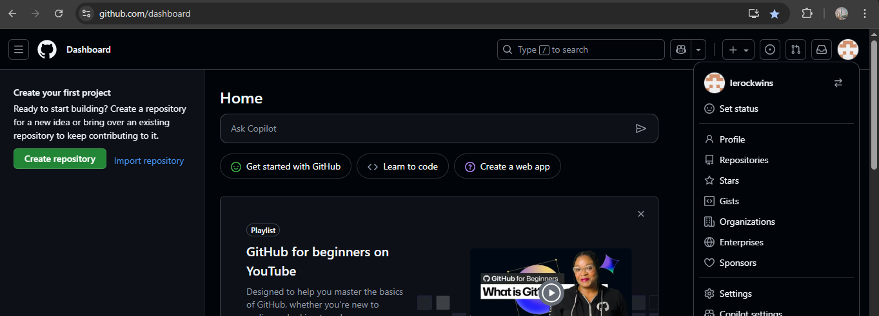

* Open a browser enter github
* And sign up
* Give a email address and create a password and gave a username nd accept box and signup
* Then its open a sign in page.

1. Create a MFA Authentication application?

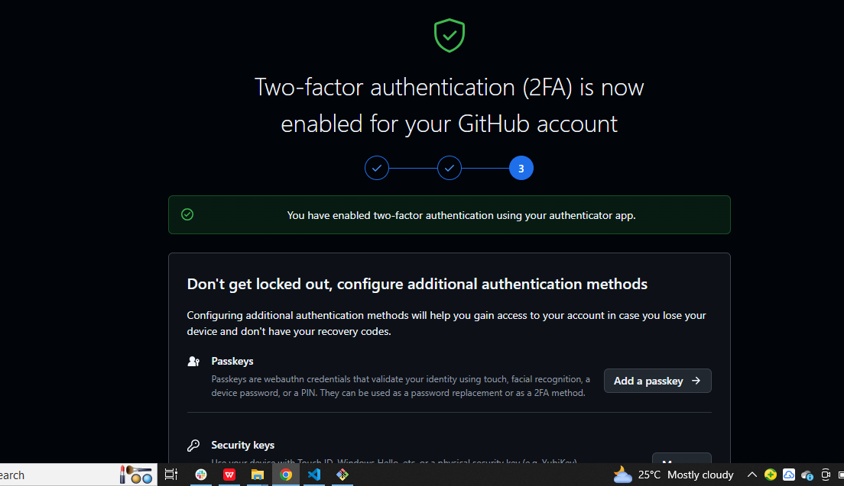

* Two factor authentication is very safe for use any personal work
* Open a git hub settings
* Go in to the two factor auntication open a scanner
* Then use your mobile and download the application
* Nd use the code nd open a application

1. Create a user name and user email in ?



Use a commands of user name and email

* Git config --user.name “Shaik Haji”
* Gitconfig --user.email [“hajishaik821@gmail.com”](mailto:\“hajishaik821@gmail.com\”)

1. Add a file in un tracking to tracking area ?

Use a command of git add a file name

And then check the git status

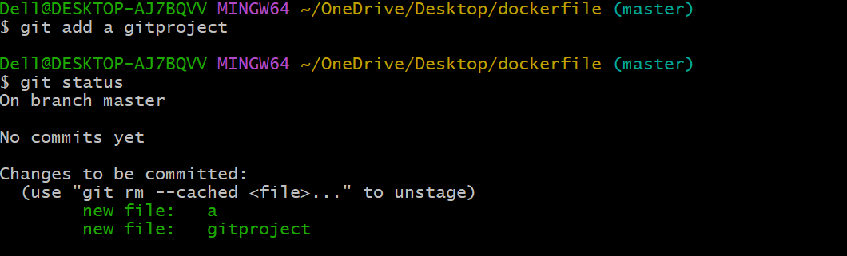

1. Add a multipul files in un tracting to tracking area ?

Use a Command of git add .

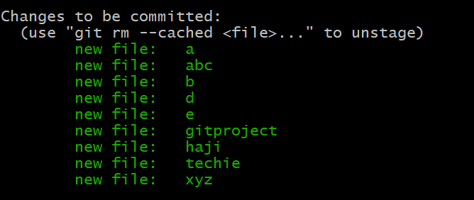

1. Commit the multiple files

Use a commit comand git commit -m “added couple of files”

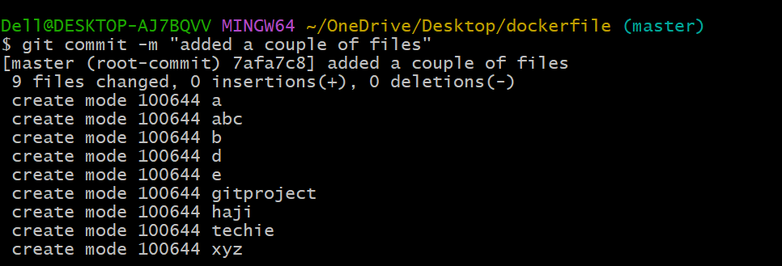

1. Get a git log ?

Use a command of git log and coomit id then one id came if we use a that link we can revert the files

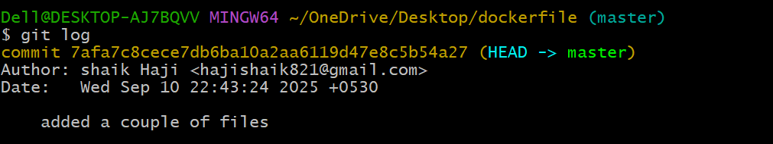

1. Delete a file

Use command of rm and file name the file will b delete

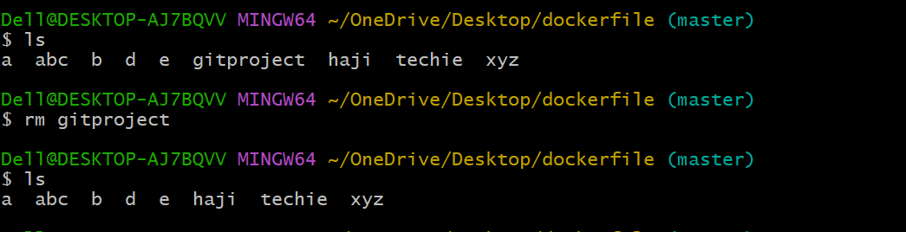

1. Revert the file

Use a command of git revert nd commit id

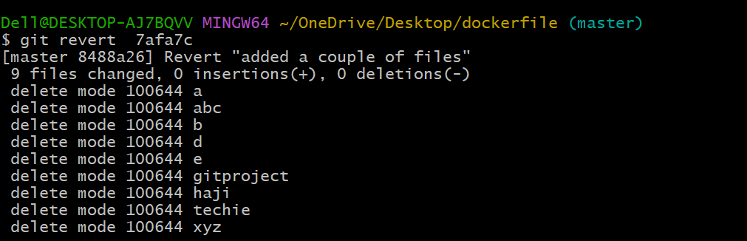

1. Git push

* Firstly generate the command of ssh-keygen press enter 2
* Then copy the public link which is start c/
* Cat public key make sure there is no spaces between in to that.
* Open a git hub browser open a setting genrate ssh key gen gave a name and copy the data
* Git remote -v
* Then copy of url and use the command of “git remote add origin copy the link”
* Get push -u origin master
* Then open a browser it will reflect to ur screen

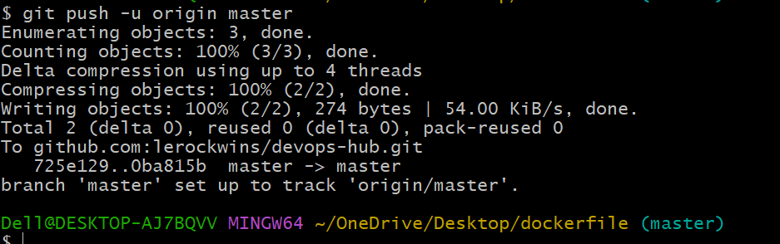



1. revert the file

* Use a command of git revert <commit id >
* Want to know the commit id “git log -4”
* It is gave recently 4 commit id

